Question 1.

1. Option a- It will give rise to a composite key by combining the two names of the instructor, but at the same time it will give rise to redundancy.

Option b- Similarly,it is also not be feasible.

Option C - It will be the most feasible option to the problem as we will be having two

Separate fact table and all the table will be in the de-normalized form.

Question 2

We will choose the option 3, as stated above for its benefits.

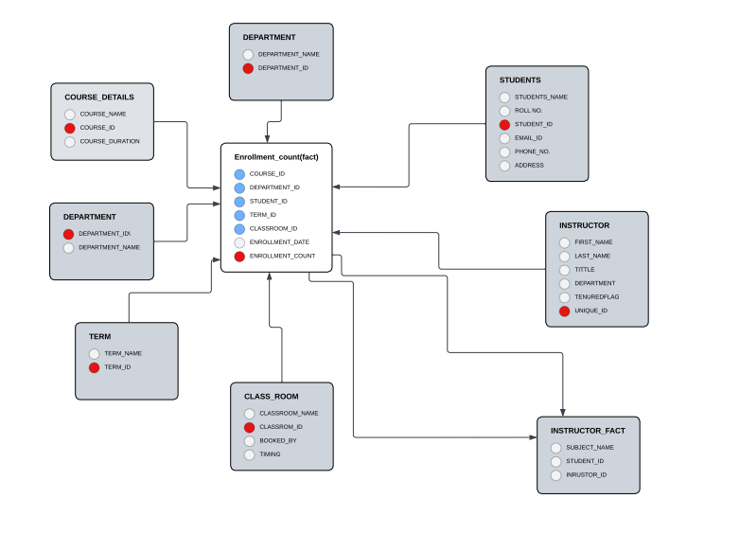

 Senario 2:

Option 3 will be best suited, as all the table is going to be in denormalized form. And that will be its strength.